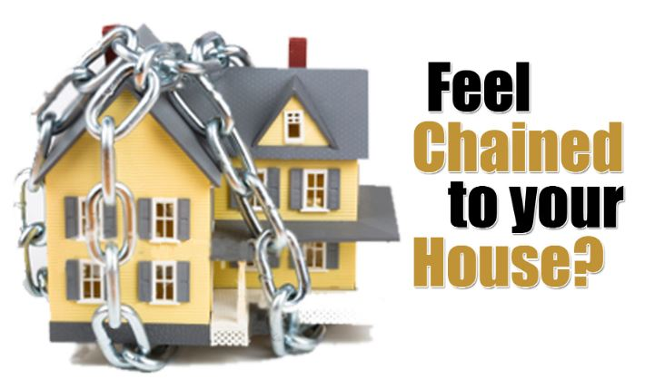
Trying to sell
BUT
IT’S NOT SELLING
Frustrated? Need Answers? Want HELP?
WARNING!!!
This may not be what you want to hear, but I promise it’s true
Once you’ve made the decision to sell, opinions on price, marketing, staging, etc. will come from everyone. Ultimately, you make the final decisions and activate the listing to sell your house. A week passes, then two, then a month, and you see where this is going. While your house is sitting on the market getting stale, every new listing in your area is going under contract in a matter of days. Maybe it’s time to have a real heart to heart talk with yourself. Here’s a few questions to ask you…
- Is the price too high?
If it’s not the condition, it’s most likely (almost ALWAYS) the price. Pricing a home for sale is tricky, especially when the owner likely suffers from “sentimental value syndrome” resulting from years of memories made with family and hours upon hours dedicated to home improvement projects. How can you know for a fact that the price is too high? Listen to feedback from potential buyers. Many buyers are looking at numerous listings in direct competition with yours. They see the good and bad of all homes toured and compare value of amenities, conditions, etc.. Check out your competition online. Think like a buyer. What do other listings have that make them a better value? Is their location better than yours? Check out square footage, annual property taxes, and utilities (electric heat, public sewer, water source, etc.). Buyers have to be able to afford the mortgage AND the cost associated with living there.
- Are there repairs needed?
You’re guaranteed to scare away potential buyers if your home is in poor condition. What are some obvious signs that a home is in poor condition? Water stains on ceilings, strong/unpleasant odors, damaged/missing roof shingles, light fixtures or outlets that don’t function properly, uneven flooring, and cracks in a foundation are common indicators. You may not want to go to the trouble of fixing all issues, but put yourself in the buyer’s place. Would you want to buy someone else’s problems?

- Did you “Primp” before you listed?
You wouldn’t go out on a date without taking a shower, choosing the right outfit, and applying your favorite scent, right? Then why wouldn’t you “Primp” your house to appeal to buyers? Buyers like wide-open spaces. Clean and uncluttered is crucial! Pleasant scents and attractive, understated décor is a must. Take the time to “Minimize”, put collectibles and seasonal items in storage, donate unwanted items to your favorite charity, and make a few extra bucks by having a yard sale. Remember, Less REALLY is More!
- It’s your job to make sure your Realtor is doing their job!
Have you looked at your listing online? Did the realtor include appealing, clear pictures? Have they provided enough detail about your house to entice people, making them want to come and tour the property? Are all the amenities of the home being marketed (pools, fenced yard, garage, finished basement, easy commute access, etc.)? Ensure your Realtor is promoting your property’s greatest assets!
- No Showings, No Offers, NO HOPE?
There’s more to selling a house than what most people realize. Skilled Realtors will employ every sales tool available, including but not limited to, online marketing, promotions on social media, print advertisement (flyers, postcards, classifieds, etc.), and hosting open houses. If you’re house has been on the market for more than 90 days with no offers and few (if any) showings, it’s time to step up your game and do some investigating.

Ask family, friends, neighbors to tour your home and give you HONEST feedback. Ask the question: “If you were looking to buy a home like mine (size, location, amenities), why would you choose NOT to make an offer on this one? Ask them to be brutally honest. If it helps to make them feel more comfortable, give them paper to write the reasons they wouldn’t want to buy the house and keep them anonymous (no names AND no hard feelings please ). Then the fix is up to you. Are the reasons given things that you can address and change (needed repairs, updates, etc.) or things that you have no control over (location issues like industrial noise, crime rate, or flooding issues).

Call on local professionals to lend a hand and don’t give up!

"I'm not a product of my circumstances. I am a product of my decisions." – Stephen Covey

Let us help you get your real estate SOLD!

